**Extract entities**

Named Entity Recognition (NER) is one of the features offered by [Azure AI Language](https://learn.microsoft.com/en-us/azure/ai-services/language-service/overview), a collection of machine learning and AI algorithms in the cloud for developing intelligent applications that involve written language. The NER feature can identify and categorize entities in unstructured text. For example: people, places, organizations, and quantities. The prebuilt NER feature has a pre-set list of [recognized entities](https://learn.microsoft.com/en-us/azure/ai-services/language-service/named-entity-recognition/concepts/named-entity-categories). The custom NER feature allows you to train the model to recognize specialized entities specific to your use case.

**Typical workflow**

To use this feature, you submit data for analysis and handle the API output in your application. Analysis is performed as-is, with no added customization to the model used on your data.

1. Create an Azure AI Language resource, which grants you access to the features offered by Azure AI Language. It generates a password (called a key) and an endpoint URL that you use to authenticate API requests.
2. Create a request using either the REST API or the client library for C#, Java, JavaScript, and Python. You can also send asynchronous calls with a batch request to combine API requests for multiple features into a single call.
3. Send the request containing your text data. Your key and endpoint are used for authentication.
4. Stream or store the response locally.

**Get started with named entity recognition**

To use named entity recognition, you submit raw unstructured text for analysis and handle the API output in your application. Analysis is performed as-is, with no additional customization to the model used on your data. There are two ways to use named entity recognition:



**Scenarios**

* Enhance search capabilities and search indexing - Customers can build knowledge graphs based on entities detected in documents to enhance document search as tags.
* Automate business processes - For example, when reviewing insurance claims, recognized entities like name and location could be highlighted to facilitate the review. Or a support ticket could be generated with a customer's name and company automatically from an email.
* Customer analysis – Determine the most popular information conveyed by customers in reviews, emails, and calls to determine the most relevant topics that get brought up and determine trends over time.

**using the client library and REST API**

**Create an Azure resource**

To use the code sample below, you'll need to deploy an Azure resource. This resource will contain a key and endpoint you'll use to authenticate the API calls you send to the Language service.

1. Use the following link to [create a language resource](https://portal.azure.com/#create/Microsoft.CognitiveServicesTextAnalytics) using the Azure portal. You will need to sign in using your Azure subscription.
2. On the **Select additional features** screen that appears, select **Continue to create your resource**.

[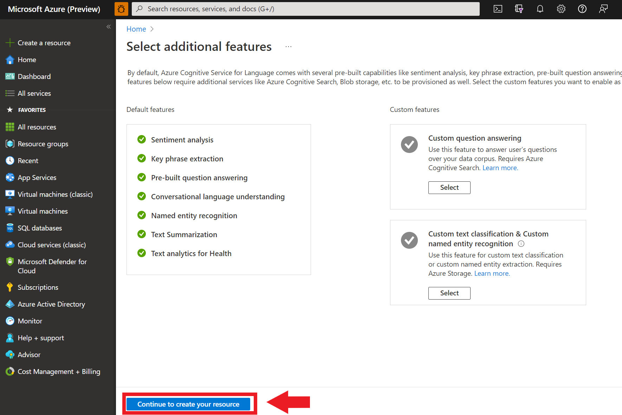](https://learn.microsoft.com/en-us/azure/ai-services/language-service/media/portal-resource-additional-features.png#lightbox)

1. In the **Create language** screen, provide the following information:

[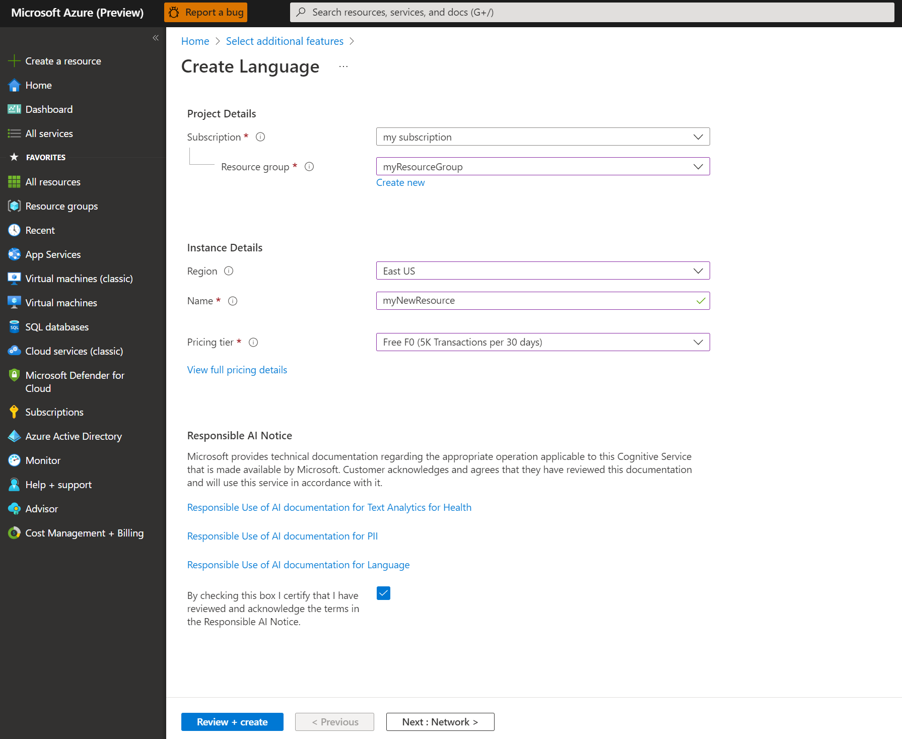](https://learn.microsoft.com/en-us/azure/ai-services/language-service/media/portal-resource-creation-details.png#lightbox)

1. Make sure the **Responsible AI Notice** checkbox is checked.
2. Select **Review + Create** at the bottom of the page.
3. In the screen that appears, make sure the validation has passed, and that you entered your information correctly. Then select **Create**.

**Get your key and endpoint**

Next you will need the key and endpoint from the resource to connect your application to the API. You'll paste your key and endpoint into the code later in the quickstart.

1. After the Language resource deploys successfully, click the **Go to Resource** button under **Next Steps**.

[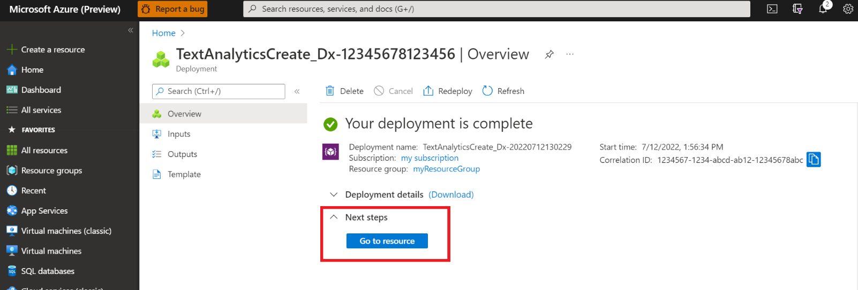](https://learn.microsoft.com/en-us/azure/ai-services/language-service/media/portal-resource-next-steps.png#lightbox)

1. On the screen for your resource, select **Keys and endpoint** on the left navigation menu. You will use one of your keys and your endpoint in the steps below.

[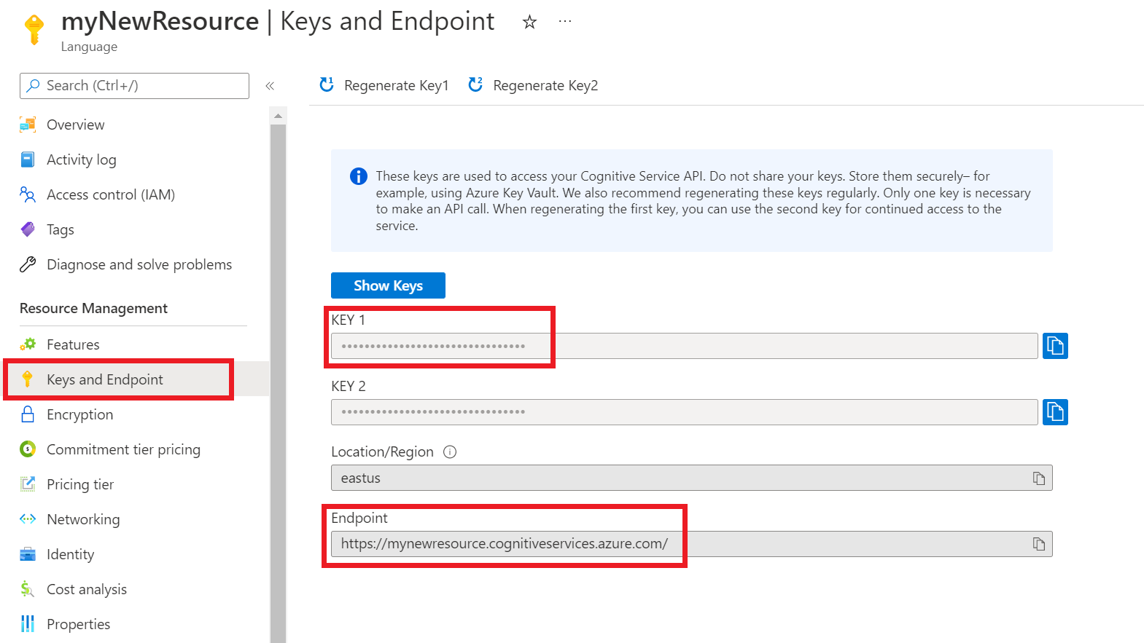](https://learn.microsoft.com/en-us/azure/ai-services/language-service/media/azure-portal-resource-credentials.png#lightbox)

**Create a new .NET Core application**

Using the Visual Studio IDE, create a new .NET Core console app. This creates a "Hello World" project with a single C# source file: *program.cs*.

Install the client library by right-clicking on the solution in the Solution Explorer and selecting Manage NuGet Packages. In the package manager that opens select Browse and search for Azure.AI.TextAnalytics. Select version 5.2.0, and then Install. You can also use the [Package Manager Console](https://learn.microsoft.com/en-us/nuget/consume-packages/install-use-packages-powershell#find-and-install-a-package).

**Code example**

**Output**

**Use Language Studio with your own text**



